Chapter 13, Problem 25.

For the network in Fig. 13.94, find Z_{ab} and I_{o}.

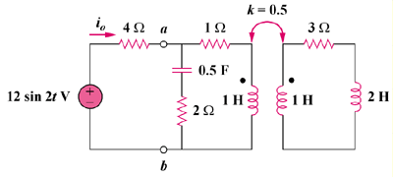

Figure 13.94
For Prob. 13.25.

